**Automated Attendance Excel Sheet Using Python**

Student Name: **Suvankar Das**

Mentor Name: **Bidyut Das**

Project Date: **28-03-2022**

This project is an approach to make a simple but effective way to keep record of the Attendance for every class in an excel sheet (CSV file), which will get updated after every use.

This is a 100 line code written in Python Programming Language and within that I’ve used total 3 Python modules:

* Pandas
* Numpy
* Datetime

There are also 3 functions which will work in 3 different scenarios:

* **allAbsent**: This will be called when all the students are absent.
* **allPresent**: This will be called when all the student are present.
* **somePresent**: This will be called when some of the students are present.

**System Information:**

* Python version: 3.10.01
* Editor used: Microsoft Visual Studio Code (64bit)
* Compiled in: VS Code Terminal
* Additional files used: One CSV file containing all the registration number and name of students.

**Folder Preview:**

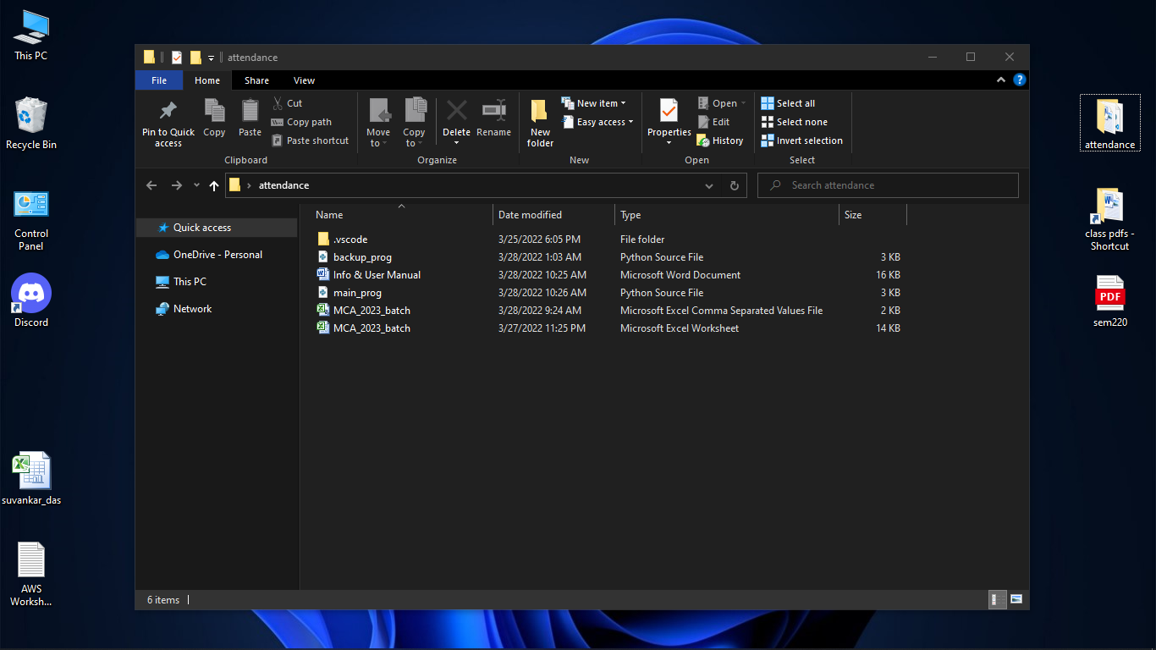

**User Manual**

**Important:**

* User needs to have python installed in his/her pc.
* Python version should be upgraded as much as possible.
* User needs to have those 3 modules included/installed.
* Place the CSV file within the same folder where *main_prog.py* program is residing.
* Please close the CSV file (excel app) while running the program.
* If a column mistakenly gets inserted, user then needs to delete it manually from the CSV file.
* While running the code open the whole folder in the editor, or edit the code by giving CSV file path/directory location where ‘MCA_2023_batch.csv’is written.
* To operate the program, use an installed python editor and run the code in terminal.
* To see the existing file, just open the CSV file.
* To perform different actions, just choose among 1, 2, 3 or 4 (numeric only) and press enter.

**Option 1:**

Run the code. And select one of the options among these. To see the existing file through code, select option 1 or just open the CSV file.

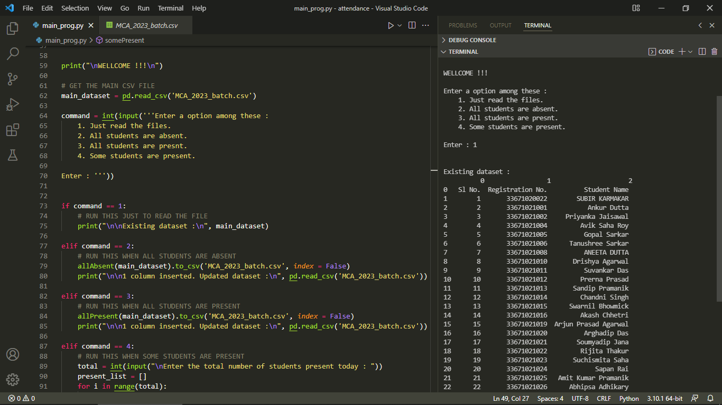

**Option 2:**

To insert a new column when all the students are absent, select option 2 and hit Enter.

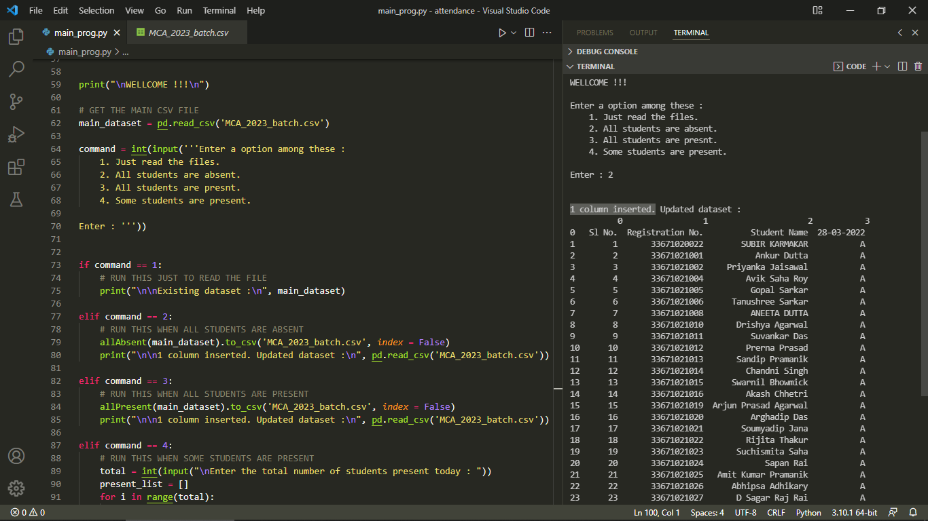

**Option 3:**

To insert a new column when all the students are present, select option 3 and hit Enter.

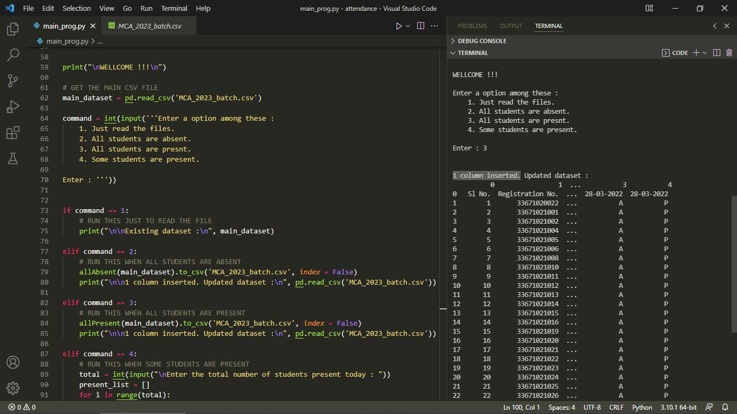

**Option 4:**

* To insert a new column when some of the students are present, select option 4 and hit Enter.
* Then first, mention the total number of students present today, followed by entering the **last 2 digits** of MAKAUT registration number for all the present students.
* Hit enter after each inputs.

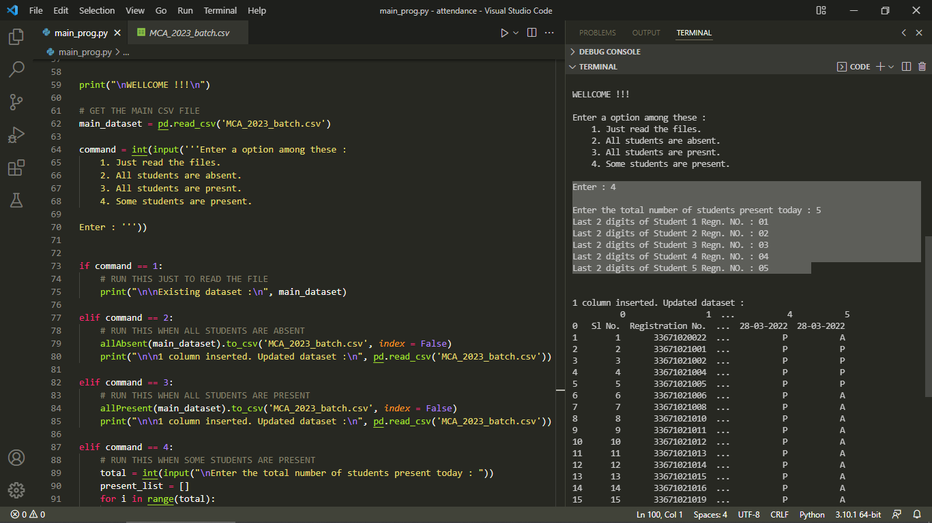

**Lastly:**

Exit the program by simply closing the editor software.

Thank You,

Suvankar Das.

MCA - 2nd Semester.

Date – 28-03-2022